1. In the previous lecture, we learnt that Apache Kafka is Distributed Publisher-Subscriber Messaging System.
   1. In any Publisher-Subscriber system, message should be stored somewhere & Publishers should be able to send messages to somewhere & Subscribers should be able to read those messages from somewhere.
   2. Brokers are responsible for all those operations.  
      Brokers takes messages from Publishers, store them and share with Subscribers.
   3. In Kafka, Publishers are called Producers. They produce messages to Kafka Brokers & Subscribers in Kafka are called Consumers as they consume messages from Kafka Brokers.
   4. On any single Physical Server, you can run multiple Kafka Brokers.  
      They will be running independently and you will be able to create Kafka Cluster on a single computer.
2. **Responsibilities of Kafka Brokers**:
   1. Receives messages from Producers.
   2. Stores those messages.
   3. Provide ability to consumers to read those messages.
3. Kafka Broker stores messages in file on Hard-Drive.
4. It is possible to create multiple producers and multiple consumers like in the Diagram:  
   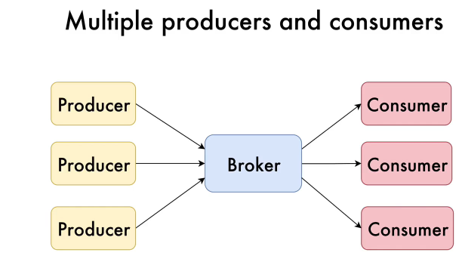
   1. Multiple Producers are able to produce messages simultaneously to the Broker &  
      multiple Consumers are able to consume messages simultaneously from the Broker.
   2. Of course, messages may be produced and consumed asynchronously at different moments of time.
   3. **Notice that there is one single weak point in the Diagram**.   
      That is Broker.   
      If the Broker breaks down, Producers & Consumers will not be able to exchange messages.  
      So, nobody runs a project like that with just a single Broker but instead Broker Cluster is created.